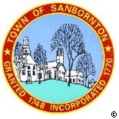
BOARD OF SELECTMEN

will have a
Nonpublic session pursuant to:
RSA 91 – A: 3 II (b)
on
July 26th 2016 at 1:30PM
in the Life Safety Building

