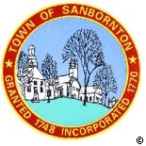
BOARD OF SELECTMEN

will have a
Nonpublic session pursuant to:
RSA 91 – A: 3 II (b)
on
July 28th 2016 at 3:00PM
in the Town Office Building

