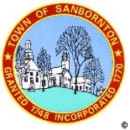
TOWN OF SANBORNTON
JOINT MEETING OF THE BOARD OF SELECTMEN
And
SANBORNTON MUNICIPAL BUDGET COMMITTEE
Town Offices
January 18th 2016 @ 5:00 p.m.

- Pledge of Allegiance
- Public Comment

- Business
  - Town of Sanbornton Fiscal Year 2017 budget
- Adjournment

