Fire Department Regionalization Study Committee Minutes

August 10, 2016 @ 7:02 PM Meeting in Fire Station

Attendees: Steve Ober, Dave DeVoy, Evelyn Auger, Dave Nickerson, Andy Sanbornton, Paul Dexter, Roger Grey

Nickerson made a motion seconded by Grey to appoint Dave DeVoy as chairman of the committee. Motion passed unanimously.

Nickerson commented that we needed a secretary to take the meeting minutes. No one expressed any enthusiasm for the job. Finally Grey said he would do the job.

Grey made a motion seconded by Nickerson to make the Fire Chief be a nonvoting member of the committee. The rational for the motion was concern that the Chief, as a paid member of the fire department, had an inherent conflict of interest with the purpose of the Committee.
A motion to table the motion failed 4 to 3.
After a spirited debate the motion passed as follows:
YES- Grey, Nickerson, Auger, DeVoy
NO- Dexter, Sanborn, Ober

After the vote, Sanborn vowed to take the issue up the selectmen and restore the Chief’s vote. Nickerson explained that the committee was advisory only and any committee votes were non-binding on the selectmen. Sanborn said he would pursue the matter with the selectmen anyway.

Grey made a motion to move the committee meetings to the town offices rather than the fire department. He explained that having the meetings at the fire department might give the voters the impression that any committee results might be biased by the fire department.
After a spirited debate the motion passed as follows:
YES – Grey, Nickerson, DeVoy
NO – Auger
ABSTAIN - Sanborn
Ober didn’t vote and left the meeting saying he thought that the committee was against the fire department and would hinder not help the department.

Work was started on a Mission Statement as follows:
- Improve FD services at the most cost effective way.

- Formulate a report of the committee results and present it to the selectmen.

- Evaluate current FD and EMS services in relation to community needs.

- Evaluate consolidation or sharing of FD and EMS services in relation to community needs.

- Study how the Sanbornton FD operates.

- What are the four Sanbornton fire districts and how do they operate.

- All information gathered for the committee must be done by the committee. Individuals are not authorized to seek information by themselves (“no freelancing”).

- Evaluate contract services i.e. EMS.

- Evaluate alternate means of FD income i.e. fees for inspecting new or replacement furnaces.

We agreed without a vote to limit meetings to 2 hours.

Grey agreed to check with the town office to see if a suitable meeting room was available.

Deter provided a tour of the station. Nickerson and Ober were not present for the tour.

9:15 PM meeting adjourned by a motion from Auger

Next meeting August 23, 2016 at 7 PM in the Sanbornton town offices.

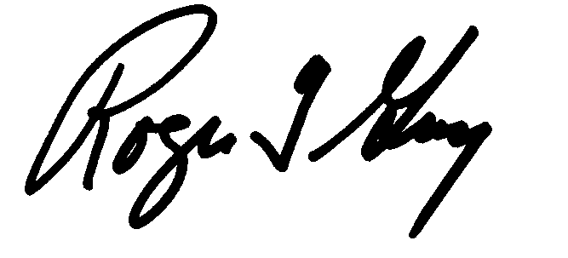Respectfully submitted
Roger Grey
Secretary

