Fire Department Regionalization Study Committee Minutes

September 6, 2016 @ 7:02 PM Meeting in Town Office

Attendees: Dave DeVoy, Evelyn Auger, Andy Sanbornton, Paul Dexter, Roger Grey

Opening discussion was how to respond to the Selectmen’s ultimatum to let the Fire Chief have a vote on the committee or face the selectmen disbanding the committee.

Dexter said the selectmen formed the committee, made him a member, and gave him a vote. Therefore, the committee had no authority to deny him a vote, and a vote to restores his vote wasn’t necessary since the committee had no authority to take it away in the first place. Further, as a tax payer in town, he was as eligible as anyone to have a right to be a voting member.

Auger stated that allowing the Chief to have a vote would “taint” any final recommendations coming from the committee.

Grey stated a concern that the Chief’s “obvious conflict of interest” would make it hard to prove to town residents that any actions suggested by the committee were completely objective.

The largest part of the meeting was devoted to discussing the Chief’s answers to the questions that were posed as a result of our first meeting (copy of written response is attached). As part of his response the Chief emphasized that the number of “hours” a fire truck/rescue vehicle was in operation was more important than the actual mileage on the vehicle i.e. a pumper might be at a fire scene stationary but running for a long period of time.

Grey made a motion that our mission statement be identical to the wording that the Selectmen used when advertising for committee members. The statement is as follows:
To examine the prospects of regionalizing the services provided by the Fire
Department with a neighboring town. To study the financial considerations
of regionalization and the impact on the fire services provided to the town.
A goal of the committee is to study and examine whether or not consolidation
of the Fire Department can provide a more effective service to the
residents of Sanbornton.
The motion was approved unanimously.

The minutes of the August 9, 2016 were approved with Sanborn abstaining.

Sanborn recommended the Chief to bring the existing Mutual Aid documents to the next meeting for examination.

The Chair asked Grey to contact Professor Daniel Bromberg from UNH to determine if he would be willing to attend one of our meetings to discuss the research work he is doing on regionalization of NH fire departments?

9:12 PM meeting adjourned by a motion from Grey.

Next meeting scheduled September 27, 2016 at 7 PM in the Sanbornton Town Offices.

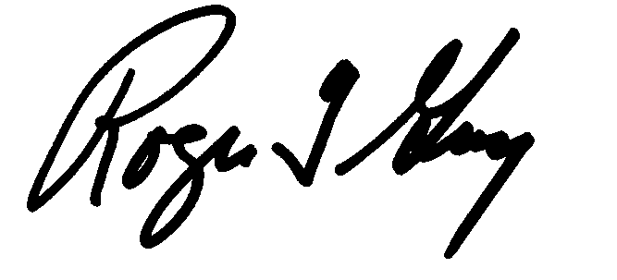Respectfully submitted
Roger Grey
Secretary

