Fire Department Regionalization Study Committee Minutes

September 27, 2016 @ 7:00 PM Meeting in Town Library

Attendees: Dave DeVoy, Evelyn Auger, Andy Sanbornton, Paul Dexter, Steve Ober, Dave Nickerson, Roger Grey, Professor Daniel Bromberg UNH, Jeff Dade UNH MPA Student

The bulk of the meeting was devoted to a PowerPoint presentation entitled “Shared Services – Identifying Real Opportunities”. The presentation was given by UNH Assistant Professor Daniel Bromberg, PhD, MPA Program Director.

The presentation was general in nature and offered a broad overview of what “shared services” might entail as well as some of the problems that might be encountered. Professor Bromberg explained that “shared services” was not necessarily for every town or community, and that turf wars, politics, and different expectations between managers and residents all play a large part in what works or what doesn’t.

The presentation emphasized that a shared services program could only be considered successful if there was:
-Equitable sharing of benefits
-Equitable sharing of costs
-All involved having equity and reciprocity (all giving and all receiving)

Professor Bromberg answered questions during and after the presentation and his information was well received by committee members.

After the conclusion of the presentation the committee members decided that the first item on the agenda for the next meeting would be to establish a list of goals for the committee i.e. possibly a survey to town residents (Grey was asked to bring to the next meeting a copy of the survey several members of the budget committee sent to town residents in 2014).

Grey made a motion seconded by Sanborn to authorize Chief Dexter to contact, after the goals have been determined, the following towns to determine their interest in starting a regionalization conversation:
Tilton-North Field
New Hampton
Laconia
Belmont
Franklin
Motion carried by unanimous vote.

8:47 PM motion to adjourn by Ober, seconded by Dexter, approved by unanimous vote

Next meeting October 11, 2016 at 7 PM in the fire house.

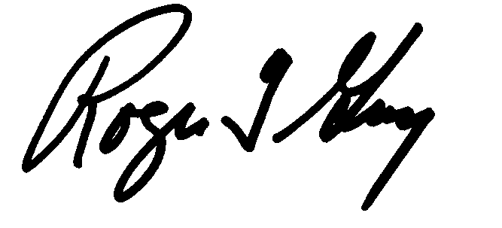Respectfully submitted
Roger Grey
Secretary

