Fire Department Regionalization Study Committee Minutes

October 11, 2016 @ 7:06 PM Meeting in Fire Station

Attendees: Dave DeVoy, Evelyn Auger, Andy Sanbornton, Paul Dexter, Steve Ober, Dave Nickerson, & Roger Grey

Ober motion seconded by Sanborn to approve the minutes of the Sept 27th meeting was approved unanimously.

Grey motion seconded by Sanborn and approved unanimously – To have the committee Chairman David DeVoy write a letter to Franklin, NH City Manager and Tilton Northfield Fire District Commissioner asking if they have an interest in discussing shared services for Fire and EMS.

Sanborn motion seconded by Grey approved unanimously - To send the following letter to the above organizations:
The Sanbornton Selectmen have charged our committee to examine the possibility of equitably sharing our Fire and EMS services with neighboring communities. Can we meet with you to discuss the possibilities?

A copy of our mission statement is attached.

Respectfully yours,

David DeVoy
Chairman
Fire Department Regionalization Study Committee
Email d_devoy@msn.com

Sanborn motion seconded by Dexter – To have future committee meetings held in the fire house on the 2nd and 4th Tuesday of every month. Motion passed as 3 to 2.
Dexter- yes
Ober – yes
Sanborn - yes
Auger – abstain
Nickerson – no
Grey – no
DeVoy – would only vote in case of a tie.

Grey was asked to follow up with Daniel Bromberg since we have not received the promised copy of his PowerPoint presentation.

9:27 PM motion to adjourn by Grey, seconded by Auger, approved unanimously

Next meeting is scheduled for October 25, 2016 at 7 PM in the fire house.

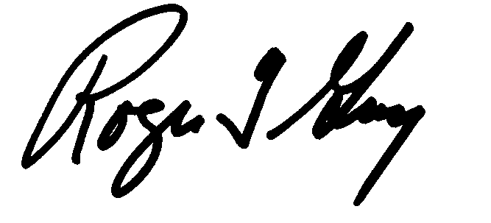Respectfully submitted
Roger Grey
Secretary

