APPROVED MINUTES

Fire Department Regionalization Study Committee Minutes

October 25, 2016 @ 7:03 PM Meeting in Fire Station

Attendees: Dave DeVoy, Evelyn Auger, Andy Sanbornton, Chief Dexter, Steve Ober, & Roger Grey

Ober motion seconded by Chief Dexter to approve the minutes of the Oct 11th meeting was approved unanimously.

DeVoy read the October 17, 2016 resignation letter from David Nickerson:

“I would like to thank the Selectmen for the opportunity to serve on the Fire Department Regionalization Committee. I am resigning from that Committee immediately.

Nickerson Replacement:
We were informed that Steve Cobb was possibly interested in being considered as a
replacement for Nickerson.

Ober motion seconded by Auger – Invite Steve Cobb to our next meeting for an interview so the committee could make a recommendation about Cobb’s candidacy to the Selectmen. Passed unanimously.

Follow up Professor Bromberg PowerPoint:
Grey twice sent emails to the professor in an effort to obtain a copy of the PowerPoint
presentation the professor made at our September 27th meeting. To date Grey has not received a response will not make any further effort to follow up.

Letters to Tilton/Northfield and Franklin:
DeVoy confirmed that letters were sent October 21st seeking an interest in discussing shared services to the above. Grey talked to the Tilton/Northfield Fire Chief and the Chief indicated that he as well as the three Tilton/Northfield Fire Commissioners were interested in participating in a discussion.

DeVoy was asked to follow up the letters if a response was not received within a reasonable length of time.

Additional letters:
We decided to send the same letters as above to the following towns:
Belmont
Meredith
Laconia
New Hampton

Fire Department Review:
The balance of the meeting was spent discussing Chief Dexter’s handouts on the Fire Department. The handouts included the following:
Proposed Fire Department Fee Schedule (fees credited to General Revenue Acct)
Sample Fire Department installation heating equipment, and fire alarm permits
911 Address Sign Permit ($10 per sign)
Fire Department Fire Truck Capital Expense Breakdown (YTD balance $195,000)
Ambulance Fund Balance Report (6/30/10 balance $238,684)
Ambulance Billing Report (YTD balance $72,614)
Ambulance Cost Analysis (approximately $426/call)

Agenda items for next meeting:
- Chief Dexter to present a recently created wage survey for EMT/firemen.
- Chief Dexter to discuss NFPA 1720: Standard for the Organization and Deployment of Fire Suppression Operations, Emergency Medical Operations and Special Operations to the Public by Volunteer Fire Departments.

9:02 PM motion to adjourn by Grey, seconded by Auger, approved unanimously

Next meeting is scheduled for November 22, 2016 at 7 PM in the fire station or sooner if we receive responses to our letters.

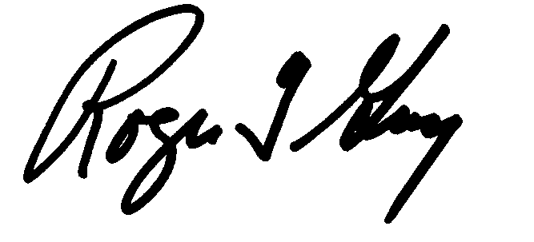Respectfully submitted
Roger Grey
Secretary

