Approved Fire Department Regionalization Study Committee Minutes

December 13, 2016 @ 7:00 PM Meeting in Fire Station

Attendees: Dave DeVoy, Andy Sanbornton, Chief Dexter, Steve Ober, Steve Cobb, & Roger Grey
Invited guests: Kevin LaChapelle, Franklin Fire Chief; Elizabeth Dragon, Franklin City Manager

We spent approximately 1.5 hrs. discussing regionalization and shared services. No decisions were made but it is apparent that Franklin and Sanbornton share many of the same problems with regards to ambulance and fire fighting services. Franklin would like to be kept informed of how our efforts are proceeding and suggested that it might be a good idea to have a joint meeting with all interested communities to discuss how our combined needs could be met. Chief LaChapelle said Franklin would have to add personnel in order to be able to make some type of regionalization commitment with Sanbornton.

Sanborn made a motion, seconded by Ober to remove from the Oct 25th meeting minutes the reason that Dave Nickerson gave for resigning from our committee. Specifically the motion was to delete the following paragraph:

“In my opinion the outcome of this Committee is a foregone conclusion as there are members on this Committee with a predetermined agenda. A researching Committee should be able to study and discuss only the facts pertaining to their mission statement. Appointments by the Select board have not allowed this to happen”.

Grey stated that he makes every effort to be fair and concise as he prepares the minutes and that it is important to let people know exactly what happens at our meetings. Sanborn stated that he didn’t think it was appropriate to have the statement is the minutes.

Motion to delete passed: Chief Dexter, Ober, Sanborn Yes; Devoy, Grey No; Cobb abstained

Grey stated that since our December 5th joint meeting was held in Belmont, NH, with the Belmont Selectmen and Ken Erickson the Laconia Fire Chief that Cary Legace, Belmont Assistant Town Administrator, agreed to take the minutes. He explained that the minutes have not yet been received, so he followed up with Legace who said the minutes were only available in draft form, but she would send them anyway. To date Grey has not received the minutes and he suspects that the selectmen want to approve them at their December 19th meeting before they are sent to us.

Laconia City Manager Scott Myers responded favorably to DeVoy’s letter requesting a meeting and in his reply asked that we answer a few questions (copy attached). DeVoy sent the questions to Chief Dexter for a response. Chief Dexter replied in an email to all committee members (copy attached) that he was apprehensive about the line of questions. We discussed whether to response and if so, how. In the end we decided that since the requested information was a matter of public record that we should answer the questions. Chief Dexter agreed to write the response.

9:05 PM motion to adjourn by Grey, seconded by Sanborn, approved unanimously

Next meeting is scheduled for December 15, 2016 at 7 PM in the New Hampton, NH office building with the New Hampton selectmen.

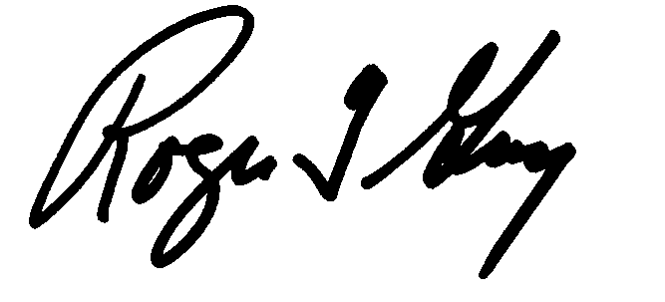Respectfully submitted
Roger Grey
Secretary

