Draft

Fire Department Regionalization Study Committee Minutes

December 27, 2016 @ 7:20 PM Meeting in Fire Station

Attendees: Chairman Dave DeVoy, Evelyn Auger, Andy Sanbornton, Chief Dexter, Steve Ober, Steve Cobb, & Roger Grey
Invited guests: Meredith, NH Selectmen Bev Lapham & Ray Moritz
Meredith, NH Fire Chief Ken Jones

We spent approximately 2 hrs. discussing regionalization and shared services. No decisions were made but it is apparent that Meredith and Sanbornton share many of the same problems with staffing the station during normal duty hours (7am to 5pm) since most of their volunteers/per-diem personnel work full time away from the station.

Meredith’s ambulance service is contracted out to Stewart’s at an approximant cost of $280k per a 3-5 year fixed contract. Stewart’s keeps at least one ambulance stationed in Meredith. Since Meredith contracts its ambulance service they do not have any EMTs on staff, only firefighters.

Meredith doesn’t see any immediate way they can share services with Sanbornton other that what the two fire departments are already doing thru Mutual Aid. Meredith personnel departed at 9:20 pm.

Meredith would like to keep informed on how we are progressing.

Motion by Chief Dexter, seconded by Ober to approve, as amended, the minutes from the Dec 13, 2016 was approved unanimously.

We again discussed Dave Nickerson’s resignation letter which resulted in Auger making the following motion seconded by Dexter:
It is the opinion of this committee that members may have come with a preconceived
agenda, but we are working together towards a fair and honest recommendation for
presentation to the Sanbornton Board of Selectmen.
Motion passed
Cobb, Chief Dexter, Auger, Devoy, Ober, Grey – yes
Sanborn - no

Devoy asked Chief Dexter if he had responded to the questions from Laconia. Chief Dexter stated he had been very busy, but he would respond.

We agreed to invite Stewards’ Ambulance in for a discussion on contract services.

Motion by Ober seconded by Cobb to adjourn @10:20pm passed unanimously.

Next meeting January 10, 2017 at 7pm in the Fire Station

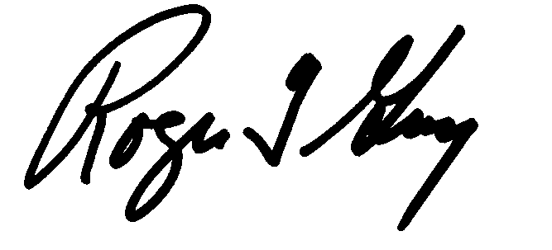Respectfully submitted
Roger Grey
Secretary

